Optionally, Find the GitHub Repo [here](https://github.com/DishangMehta11/Java_Assignment.git).

1. Write a function to print the factorial of a number.



**Output:**

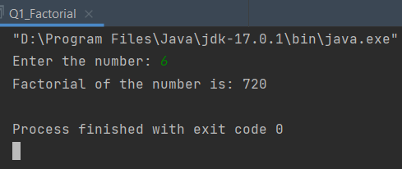

1. Calculate simple interest. Accept P, T, R from user.



**Output:**

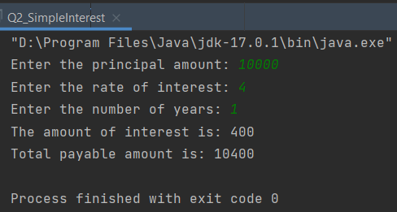

1. To check if the given number is Armstrong or not.
2. To print all Armstrong numbers between two range.



**Output:**

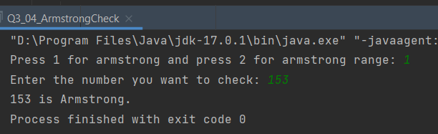

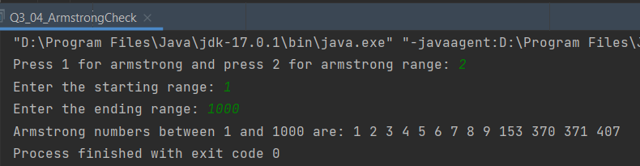

1. To check if a given number is Prime. Use function.



**Output:**

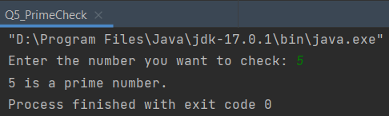

1. Print all prime numbers between two range.



**Output:**

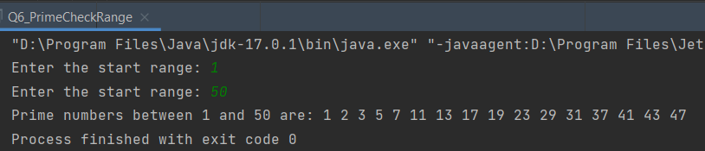

1. To print $n^{th}$ prime number.



**Output:**

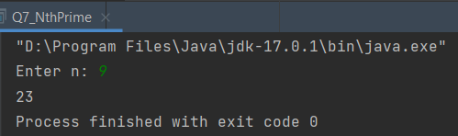

1. To print all composite numbers within $n$. Use function.



**Output:**

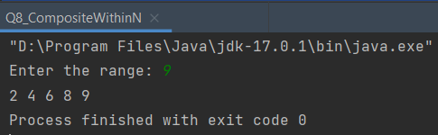

1. Find the area of circle.



**Output:**

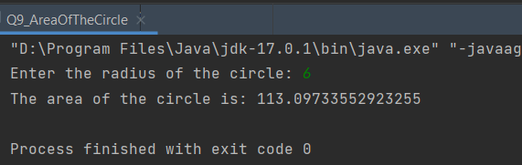

1. To print all Fibonacci numbers till $n$. Use function.



**Output:**

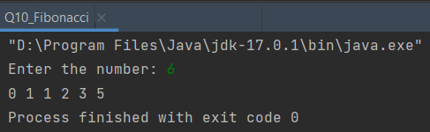

1. To print $n^{th}$ Fibonacci number.



**Output:**

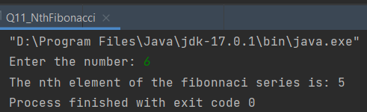

1. Sum of square of $1^{st} n$ natural numbers using function.



**Output:**

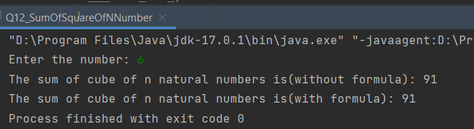

1. Sum of cube of $1^{st} n$ natural numbers using function.



**Output:**

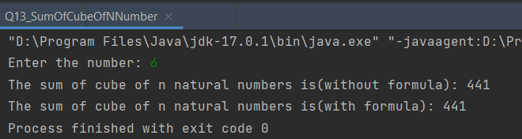

1. To check Palindrome. Use function.



**Output:**

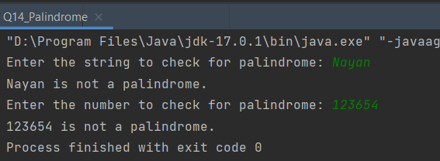

1. Reverse words in a long string using function.



**Output:**

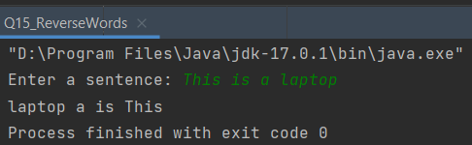

1. To remove a character from a string at specific position and print the remaining string.



**Output:**

